**A MINI PROJECTREPORT**

**ON**

**“HAND SIGN DETECTION”**

Submitted in the partial fulfillment of the requirements for

The degree of

**BACHELOR OF ENGINEERING IN COMPUTER ENGINEERING**

**By**

1. ANURAG WAGH

2) OM SAWANT

3) VIRAJ TAYWADE

1. ABHISHEK PRAJAPATI

**UNDER THE GUIDANCE OF**

**DR. ANJALI DADHICH**



Department of Computer Engineering  
Saraswati College of Engineering, Kharghar, Navi Mumbai  
University of Mumbai  
2022-23

**Saraswati College of Engineering, Kharghar**

**Vision:**

To be universally accepted as autonomous center of learning in Engineering Education and Research.

**Mission:**

* To educate students to become responsible and quality technocrats to fulfil society and industry needs.
* To nurture student’s creativity and skills for taking up challenges in all facets of life.

**_______________________________________________**

**Department of Computer Engineering**

**Vision:**

To be among renowned institution in Computer Engineering Education and Research by developing globally competent graduates.

**Mission:**

* To produce quality Engineering graduates by imparting quality training, hands on experience and value education.
* To pursue research and new technologies in Computer Engineering and across interdisciplinary areas that extends the scope of Computer Engineering and benefit humanity.
* To provide stimulating learning ambience to enhance innovative ideas, problem solving ability, leadership qualities, team-spirit and ethical responsibilities.

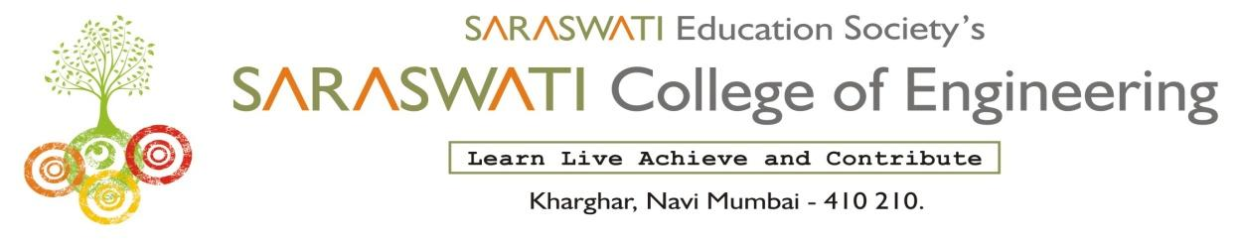

**DEPARTMENT OF COMPUTER ENGINEERING**

**PROGRAM EDUCATIONAL OBJECTIVE’S**

1. To embed a strong foundation of Computer Engineering fundamentals to identify, solve, analyze and design real time engineering problems as a professional or entrepreneur for the benefit of society.
2. To motivate and prepare students for lifelong learning & research to manifest global competitiveness.
3. To equip students with communication, teamwork and leadership skills to accept challenges in all the facets of life ethically.



**DEPARTMENT OF COMPUTER ENGINEERING**

**PROGRAM OUTCOMES**

1. Apply the knowledge of Mathematics, Science and Engineering Fundamentals to solve complex Computer Engineering Problems.
2. Identify, formulate and analyze Computer Engineering Problems and derive conclusion using First Principle of Mathematics, Engineering Science and Computer Science.
3. Investigate Complex Computer Engineering problems to find appropriate solution leading to valid conclusion.
4. Design a software System, components, Process to meet specified needs with appropriate attention to health and Safety Standards, Environmental and Societal Considerations.
5. Create, select and apply appropriate techniques, resources and advance Engineering software to analyze tools and design for Computer Engineering Problems.
6. Understand the Impact of Computer Engineering solution on society and environment for Sustainable development.
7. Understand Societal, health, Safety, cultural, Legal issues and Responsibilities relevant to Engineering Profession.
8. Apply Professional ethics, accountability and equity in Engineering Profession.
9. Work Effectively as a member and leader in multidisciplinary team for a common goal.
10. Communicate effectively within a Profession and Society at large.
11. Appropriately incorporate principles of Management and Finance in one’s own Work.
12. Identify educational needs and engage in lifelong learning in a Changing World of Technology.



**DEPARTMENT OF COMPUTER ENGINEERING**

**PROGRAMME SPECIFIC OUTCOME**

1. Formulate and analyze complex engineering problems in computer engineering (Networking/Big data/ Intelligent Systems/Cloud Computing/Real time systems).
2. Plan and develop efficient, reliable, secure and customized application software using cost effective emerging software tools ethically.

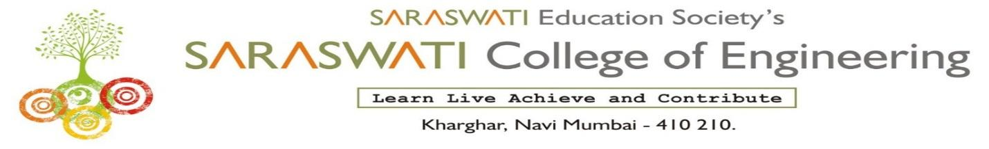

**(Approved by AICTE, recg. By Maharashtra Govt. DTE ,Affiliated to Mumbai University)**

**PLOT NO. 46/46A, SECTOR NO 5, BEHIND MSEB SUBSTATION, KHARGHAR, NAVI MUMBAI-410210**

**Tel. : 022-27743706 to 11 * Fax : 022-27743712 * Website: www.sce.edu.in**

**CERTIFICATE**

*This is to certify that the requirements for the mini project report entitled ”* ***Hand sign Detection****” have been successfully completed by the following students:*

Roll numbers Name

76 Anurag Wagh

64 Om Sawant

62 Viraj Taywade

60 Abhishek Prajapati

In partial fulfillment of Sem – V, **Bachelor of Engineering of Mumbai University in Computer Engineering** of Saraswati college of Engineering , Kharghar during the academic year 2022-23

**Internal Guide**  **External Examiner**

Dr. Anjali Dadhich

**Mini Project Co-ordinator**  **Head of Department**

Dr. Anjali Dadhich Prof. Sujata Bhairnallykar

**DECLARATION**

I declare that this written submission represents my ideas in my own words and where others ideas or words have been included. I have adequately cited and referenced the original sources. I also declare that I have adhered to all principles of academic honesty and integrity and have not misrepresented or fabricated or falsified any idea/data/fact/source in my submission. I understand that any violation of the above will be cause for disciplinary action by the Institute and can also evoke penal action from the sources which have thus not been properly cited or from whom proper permission has not been taken when needed.

1. Anurag Wagh
2. Om Sawant
3. Viraj Taywade
4. Abhishek Prajapati

Date:

**ACKNOWLEDGEMENT**

After the completion of this work, words are not enough to express feelings about all those who helped us to reach goal.

It’s a great pleasure and moment of immense satisfaction for us to express my profound gratitude to **MiniProject Guide**, **Dr.Anjali Dadhich**, whose constant encouragement enabled us to work enthusiastically. His perpetual motivation, patience and excellent expertise in discussion during progress of the project work have benefited us to an extent, which is beyond expression.

We would also like to give our sincere thanks to **Prof.Sujata Bhairnallykar, Head of Department**, and **Dr.Anjali Dadhich, Mini Project co-coordinator** from Department of Computer Engineering, Saraswati college of Engineering, Kharghar, Navi Mumbai, for their guidance, encouragement and support during a project.

I am thankful to **Dr. Manjusha Deshmukh, Principal,** Saraswati College of Engineering,Kharghar, Navi Mumbai for providing an outstanding academic environment, also for providing the adequate facilities.

Last but not the least we would also like to thank all the staffs of Saraswati college of Engineering (Computer Engineering Department) for their valuable guidance with their interest and valuable suggestions brightened us.

1. Anurag Wagh

2. Om Sawant

1. Viraj Taywade
2. Abhishek Prajapati

**ABSTRACT**

Creating a desktop application that uses a computer's webcam to capture the American Sign Language (ASL) signer's gestures and translate them into corresponding text and speech in real time. The translated sign language gesture will be obtained in the text, which is further converted to sound. In this way, we implement a sign language translator for fingerspelling. We use a convolutional neural network (CNN) to enable gesture detection. CNN is highly effective in solving computer vision problems and is able to detect desired features with a high degree of accuracy after sufficient training.

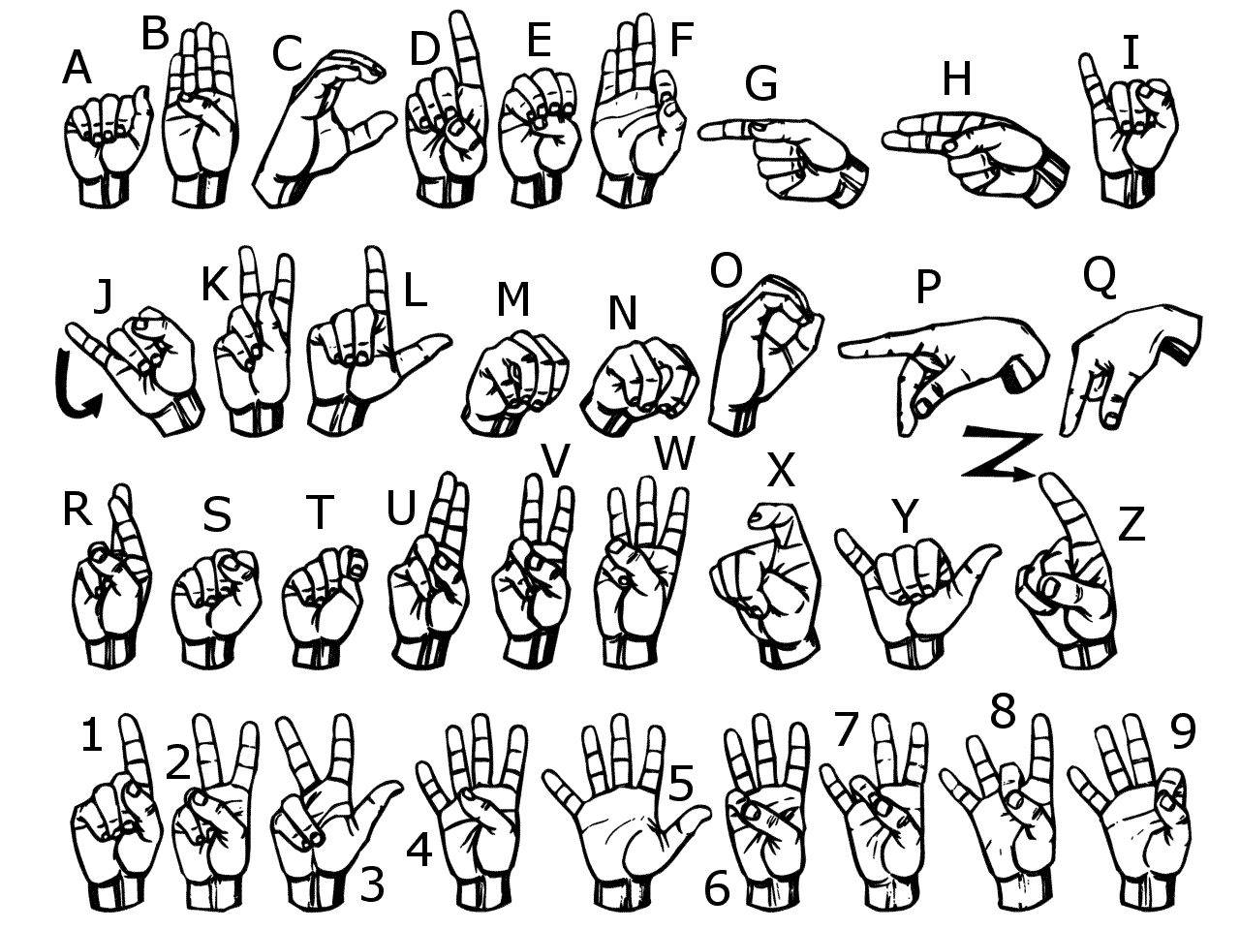

**Fig: American Sign Language**

**Table of Contents**

|  |  |
| --- | --- |
|  |  |
| **List of Figures ………………………………………………………………………...** | **1** |
| **1. Introduction ………………………………………………………………………..** | **2-4** |
| **1.1 General ……………………………………………………………………..….** | **2** |
| **1.2 Objective and problem statement ……………………………........................** | **4** |
| **2. Methodology ……………………………………………………………….............** | **5** |
| **2.1 Algorithmic details .…………………………………………………………...** | **5** |
| **2.2 Hardware and Software requirements……………………………..............** | **7** |
| **3. Implementation and Results …………………………………………………….** | **8-14** |
| **3.1. Implementation ....………………………………………………….................** | **8** |
| **3.2. Results ...………………………………………………………………............** | **11** |
| **4.Conclusion and Future Scope……………………………………………………..** | **15-16** |
| **5. References………………………………………………………………...........** | **17** |

# List of Figures

|  |  |  |
| --- | --- | --- |
| **Figure No.** | **Name** | **Page No.** |
| 2.1.1 | Flowchart | 4 |
| 3.2.1 | Hand Detected and Scanning points. | 11 |
| 3.2.2 | Crop image on whiteboard. | 11 |
| 3.2.3 | Saving image for various characters. | 12 |
| 3.2.4 | Specific image is store in specific folder. | 12 |
| 3.2.5 | Training data on Teachable Machine. | 13 |
| 3.2.6 | Exporting Models. | 13 |
| 3.2.7 | Hand Detection and Scanning point. | 14 |
| 3.2.8 | Hand Detection and letter recognize. | 14 |

# 

**CHAPTER 1**

# INTRODUCTION

In recent years, the use of different types of controls besides mouse and keyboard has become common. A number of devices are available for specific tasks or applications, one interaction form that has gained popularity is the area of natural interactions between humans and machines. Web browsers, video games, Virtual Reality (VR) environments and a diverse set of tools have taken advantage of users’ natural interactions, e.g., voice control, touchpads, haptic devices, cameras, etc. Immersing the user into the systems or environments in a natural way is the goal of this type of research. Natural interaction involves the use of a user’s body without additional hardware. This is called Natural User Interface (NUI). By using sensors and capturing the diverse interactions of the user’s body it is possible to recognize commands and perform required tasks in a system.

NUI is the use of body and hand gestures, therefore Hand Gesture Recognition (HGR) is an essential component of this kind of system. Smartphones and tablets are controlled by touching the device and performing gestures. Another method for NUIs is the use of cameras to detect the user’s different body parts like the Xbox Kinect camera does. The hands of the user can provide a collection of gestures and if the gesture is recognized, allow control of applications. Segmenting the hands from cameras and knowing which gesture is being performed lead scientists to one of the areas in our research community that has been studied for years: Sign Language Recognition (SLR).

Sign Language (SL) is not commonly learned by non-mute people, thus, mute people have problems communicating. Usually, people do not learn it if there is no mute person in their relation circles or if it is not required for their job. When 3 they engage with a mute person the communication can be hard and tedious. As an example, a mute individual goes to an interview: if the interviewer does not know SL the common approach is to hire a translator. This action creates some problems, as hiring can be expensive and scheduling an appointment with three people, depending on the circumstances, difficult. This is where image recognition techniques play an important role by automatizing the process of identifying signs. The focus of this research is on this type of problem: facilitating communication via SL by automating the transcription of SL without the need for a human translator.

Even though SLR research using machines started a long time ago, because of the challenge of the problem, there is not a full automatic Sign Language transcriptor system. Dealing with the scalability of the problem (number of gestures and variations, movement, face expressions and contextual meaning) is not trivial. This is one reason why previous studies focus on limited datasets of gestures and users. SL has hundreds of symbols to represent many concepts. These symbols have variations that change the meaning of them depending on the context and what the performer wants to say: pointing, arm moving and face expressions are examples of variances. As an example of meaning variation of a sign, consider the phrase not yet, the sign for the phrase requires the tongue touching the lower lip and the head rotating from side to side. If both actions are not performed the meaning of the sign becomes late.

The goal of this research is to study the performance of a Convolutional Neural Network (CNN) recognizing and transcribing into text SL images (gestures performed by a hand). Given the broad scope of this task I limited the scope of the study to American Sign Language (ASL) letters and number symbols. Since some of the 4 gestures (J and Z) need some movement to be performed I discarded them. I kept all the gestures that can be performed in a static manner. I defined a scene which has also been predefined in an “ideal world” to capture the images in a consistent way. This avoids errors in the image capture step. From the limited and ideal scenario, adding more gestures and more features (like hand and arm movement, and face expressions) to the system and modifying the environment into a more intricate one will allow the generalization of the problem, resulting in a more robust system.

The research work presented in this document is focused on creating a classification model for hand letter and number gestures and provides a new dataset for hand gesture recognition. The model detects local features of the hand images and recognizes the gesture in each of the images. The created dataset has fixed size images, the hands are centered, and the values of the hands normalized. Since all the preprocessing steps have been done to the images, all the images are in the same coordinates so they can be compared against each other directly.

## 

## 1.2 OBJECTIVE AND PROBLEM STATEMENT

**Problem Statement**

In our progressive society, it is necessary to socialize with all people to whether for recreation or for a purpose. Communication is important for every human being. However, people who have a hearing disability and/or a speech disability need a different way to communicate other than vocal communication. They resort to sign language to communicate with each other. However, Sign Language requires a lot of training to be understood and learn and not every person may understand what the sign language gestures mean. Learning sign language is also time consuming as there are no effective, portable tool for recognizing sign language. Hearing or Speech disabled people who know Sign Language require a translator who also knows Sign Language to explain their thoughts to other people in an effective manner. To help overcome these problems, this system helps hearing or speech disabled people to learn as well as translate their sign language.

**Objective**

The objective of our project is to develop a concept of virtual talking system without sensor for people who in need, this concept achieving a by using image processing and human hand gesture input. This mainly helps to people who can’t talk with other people.

**CHAPTER 2**

# METHODOLOGY

## 2.1 ALGORITHMIC DETAILS

**Algorithm For Hand Detection.**

S1: First Camera will Open and Detect hand in the Camera.

S2: After the hand is Detected it will first Scan the Hand.

S3: In the Scanning it will Check the Scanning points.

S4: The All the letter which has to be detect in save in the Data collection Folder.

S5: Try the different American sign Language and that sign will get Detected

S6: As the hand sign is detected , it will speak that Detected letter.

Stop

**Flowchart:-**

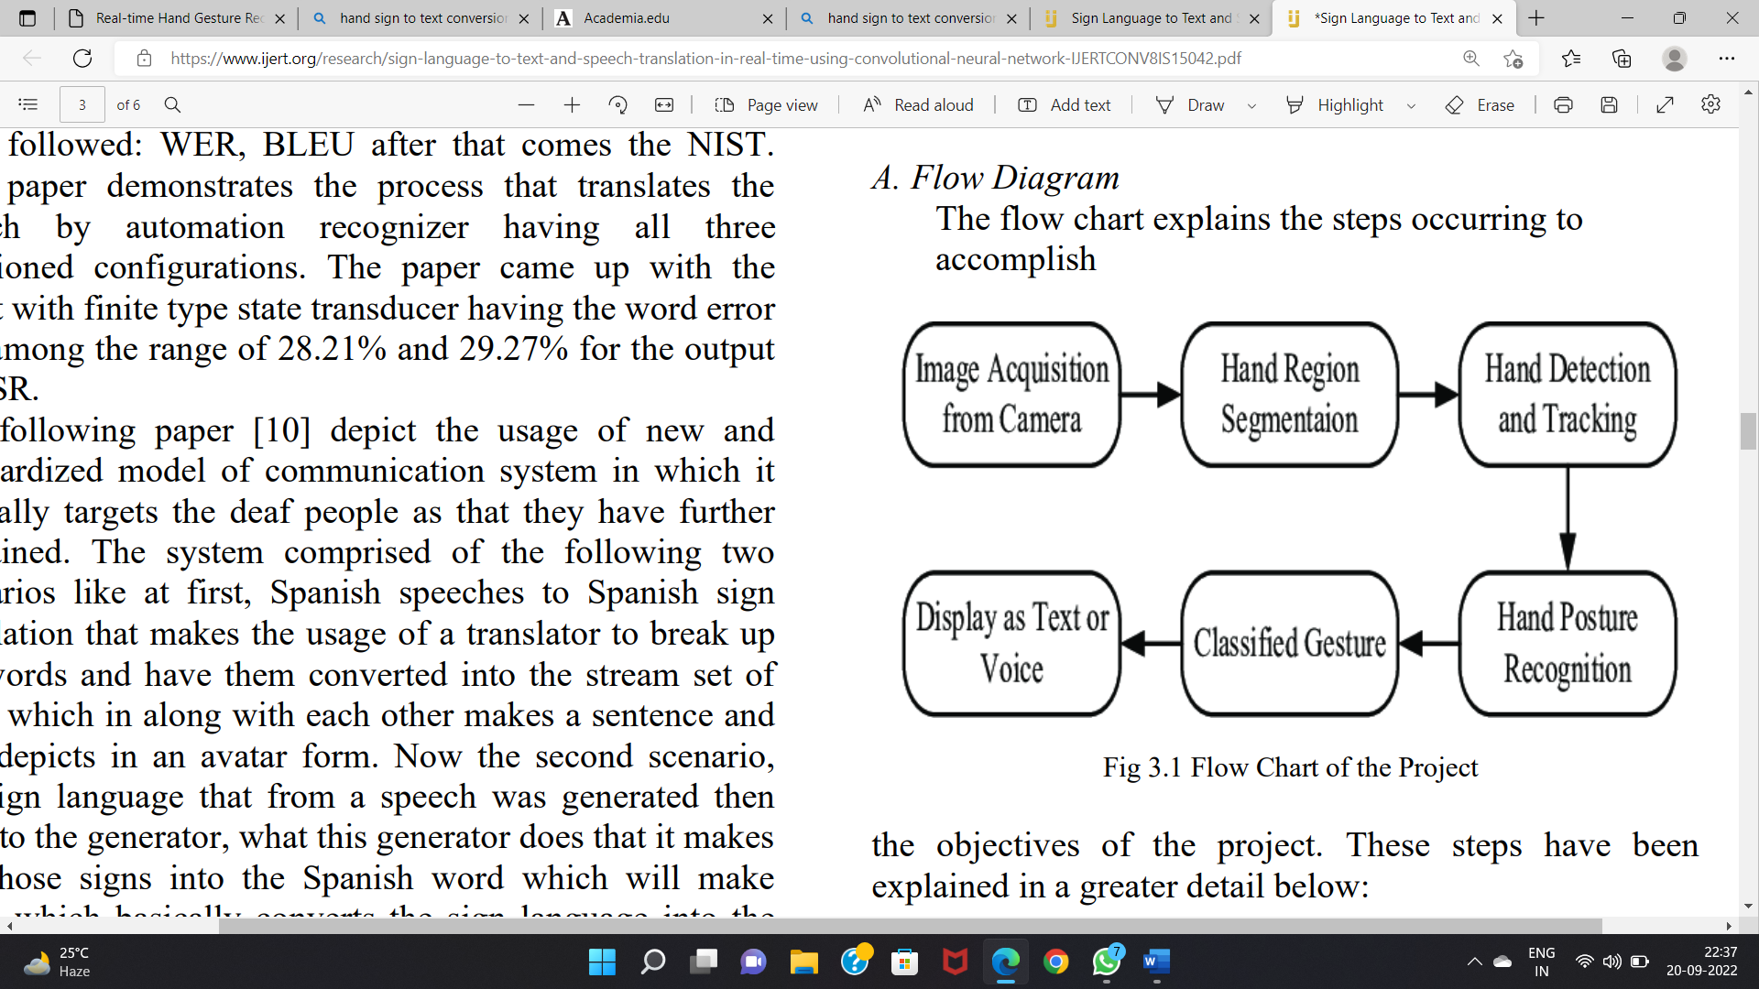

## 2.2 HARDWARE AND SOFTWARE REQUIREMENTS

**2.2.1 HARDWARE REQUIREMENTS**

1. RAM : 512 MB RAM
2. Hard Drive : 40 GB Hard Drive
3. Processor : Intel Core 2 Processor
4. camera module (Webcam)
5. Projector
6. Colour Markers

**2.2.2 SOFTWARE REQUIREMENTS**

1. Pycharm

2. Visual Studio

**CHAPTER 3**

# IMPLEMENTATION AND RESULTS

**3.1 IMPLEMENTATION:**

**DataConnection.py**

import cv2  
from cvzone.HandTrackingModule import HandDetector  
import numpy as np  
import math  
import time  
  
cap = cv2.VideoCapture(0)  
detector = HandDetector(maxHands=1)  
  
offset = 20  
imgsize = 300  
  
folder = "Data/C"  
counter = 0  
while True:  
 success, img = cap.read()  
 hands, img = detector.findHands(img)  
 if hands:  
 hand = hands[0]  
 x, y, w, h = hand['bbox']  
  
 imgWhite = np.ones((imgsize, imgsize, 3), np.uint8) * 255  
 imgCrop = img[y - offset:y + h + offset, x - offset:x + w + offset]  
  
 imgCropShape = imgCrop.shape

aspectRatio = h / w  
  
 if aspectRatio > 1:  
 k = imgsize / h  
 wCal = math.ceil(k * w)  
 imgResize = cv2.resize(imgCrop, (wCal, imgsize))  
 imgResizeShape = imgResize.shape  
 wGap = math.ceil((imgsize-wCal)/2)  
 imgWhite[:, wGap:wCal+wGap] = imgResize  
  
 else:  
 k = imgsize / w  
 hCal = math.ceil(k * h)  
 imgResize = cv2.resize(imgCrop, (imgsize, hCal))  
 imgResizeShape = imgResize.shape  
 hGap = math.ceil((imgsize - hCal) / 2)  
 imgWhite[hGap:hCal + hGap, :] = imgResize  
  
 cv2.imshow("ImageCrop", imgCrop)  
 cv2.imshow("ImageWhite", imgWhite)  
  
cv2.imshow("Image", img)  
key = cv2.waitKey(1)  
if key == (ord("s")):  
 counter += 1  
 cv2.imwrite(f'{folder}/Image_{time.time()}.jpg', imgWhite)  
 print(counter)

Test.py

import cv2  
from cvzone.ClassificationModule import Classifier  
from cvzone.HandTrackingModule import HandDetector  
import numpy as np  
import math  
import pyttsx3  
  
cap = cv2.VideoCapture(0)  
detector = HandDetector(maxHands=1)  
classifier = Classifier("Model/keras_model.h5", "Model/labels.txt")  
  
offset = 20  
imgsize = 300  
  
folder = "Data"  
counter = 0  
  
labels = ["1", "2", "3", "A", "B", "C", "F", "G"]  
while True:  
 success, img = cap.read()  
 imgOutput = img.copy()  
 hands, img = detector.findHands(img)  
 if hands:  
 hand = hands[0]  
 x, y, w, h = hand['bbox']  
  
 imgWhite = np.ones((imgsize, imgsize, 3), np.uint8) * 255  
 imgCrop = img[y - offset:y + h + offset, x - offset:x + w + offset]

imgCropShape = imgCrop.shape  
  
aspectRatio = h / w  
  
if aspectRatio > 1:  
 k = imgsize / h  
 wCal = math.ceil(k * w)  
 imgResize = cv2.resize(imgCrop, (wCal, imgsize))  
 imgResizeShape = imgResize.shape  
 wGap = math.ceil((imgsize-wCal)/2)  
 imgWhite[:, wGap:wCal+wGap] = imgResize  
 prediction, index = classifier.getPrediction(imgWhite, draw=False)  
 print(prediction, index)  
  
else:  
 k = imgsize / w  
 hCal = math.ceil(k * h)  
 imgResize = cv2.resize(imgCrop, (imgsize, hCal))  
 imgResizeShape = imgResize.shape  
 hGap = math.ceil((imgsize - hCal) / 2)  
 imgWhite[hGap:hCal + hGap, :] = imgResize  
 prediction, index = classifier.getPrediction(imgWhite, draw=False)

Txt1 = cv2.putText(imgOutput, labels[index], [x, y - 26], cv2.FONT_HERSHEY_COMPLEX, 1.7, (255, 0, 255), 2)  
 cv2.rectangle(imgOutput, (x - offset, y - offset),  
 (x + w + offset, y + h + offset), (255, 0, 255), 4)  
  
 textspeech = pyttsx3.init()  
 textspeech.say(labels[index])  
 textspeech.runAndWait()  
  
 cv2.imshow("ImageCrop", imgCrop)  
 cv2.imshow("ImageWhite", imgWhite)  
  
cv2.imshow("Image", imgOutput)  
cv2.waitKey(1)

**3.2 RESULTS:**

**1. Hand is detected and Scan the Points.**

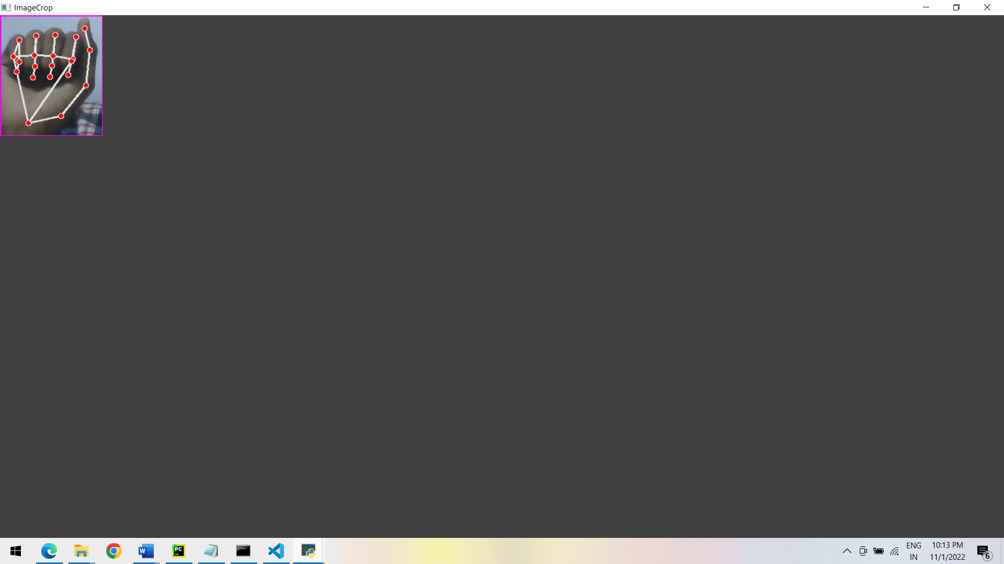

**Fig 3.2.1 Hand Detect and Scanning the points**

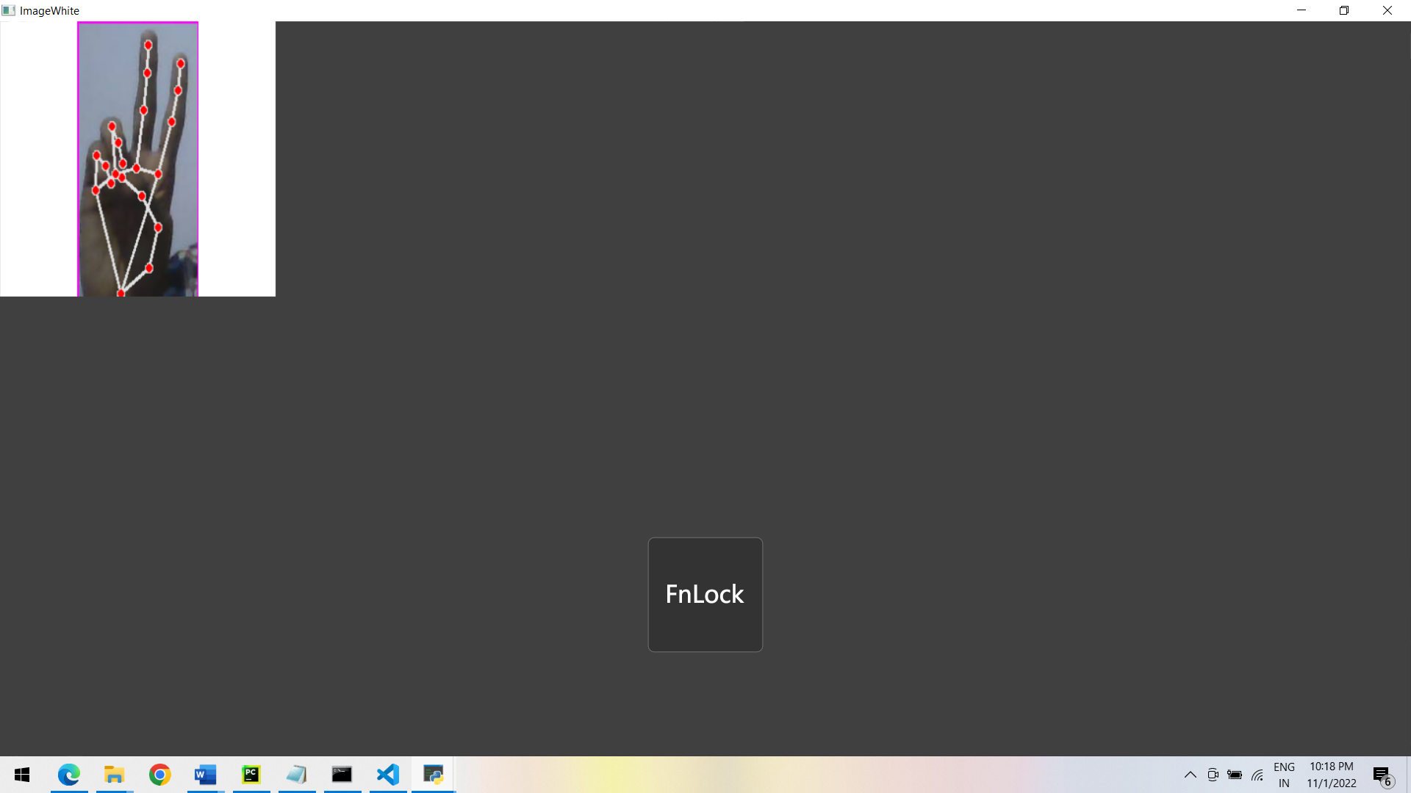

**Fig 3.2.2 Image Crop on White Board**

**2. Save Images And Trained the Data**

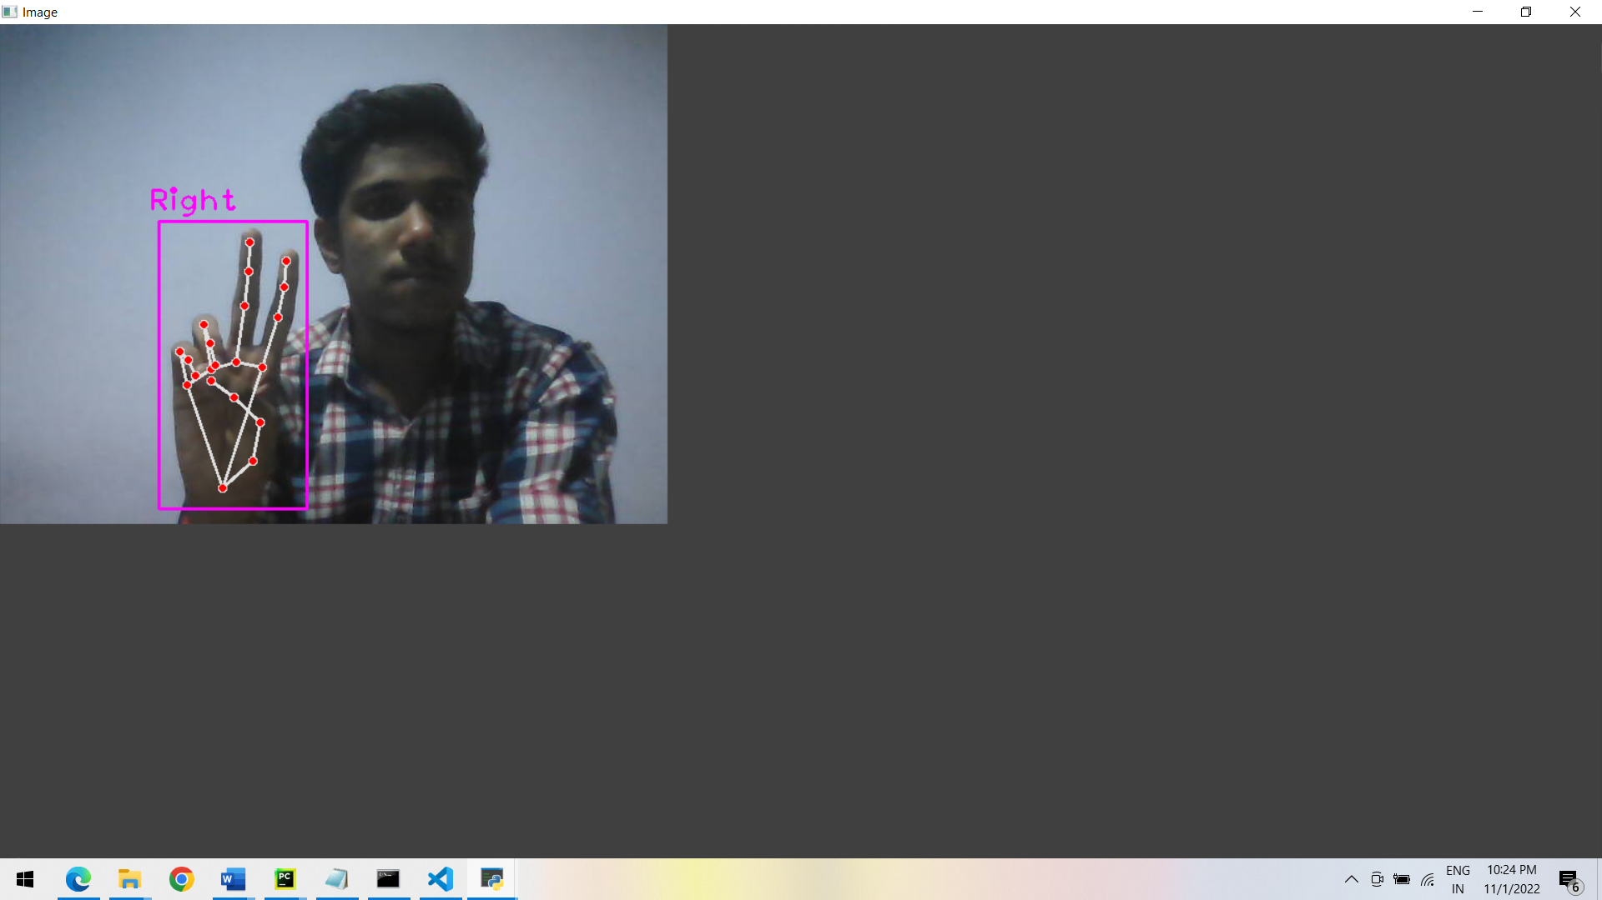

**Fig 3.2.3 Saving Images for Various Character**

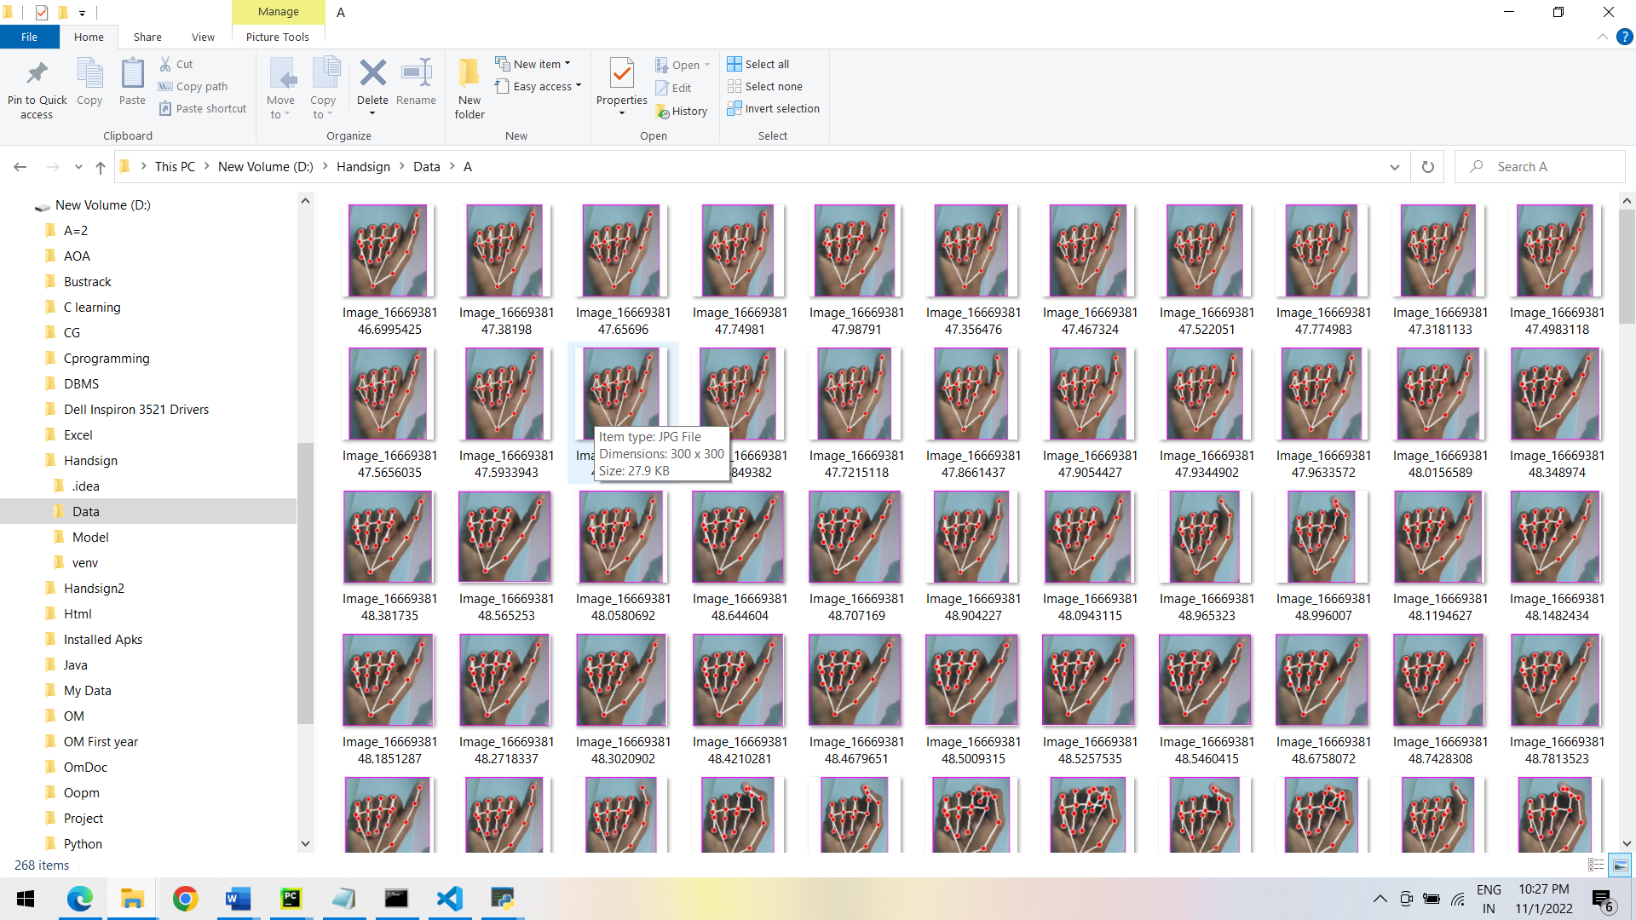

**Fig 3.2.4 Specifics image store in specific folder**

**2.1 Training the data**

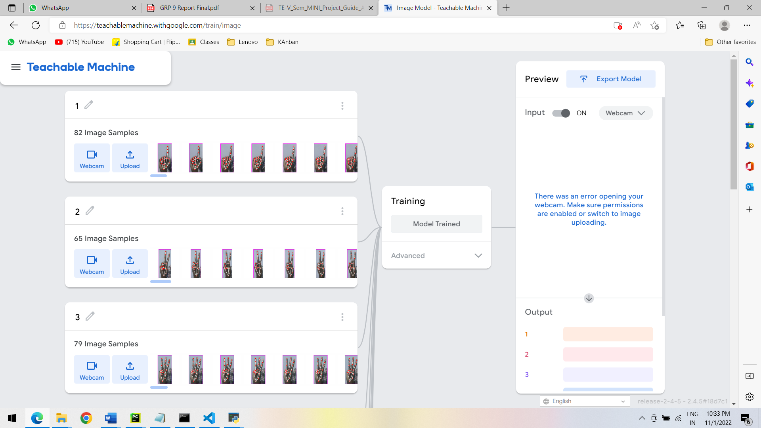

**Fig 3.2.5 Training data on Teachable Machine**

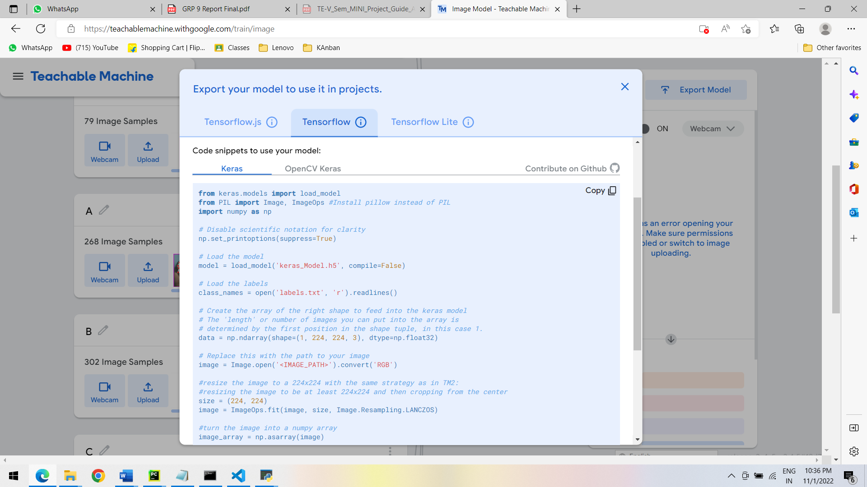

**Fig 3.2.6 Exporting Model**

**3. Hand Sign Detection**

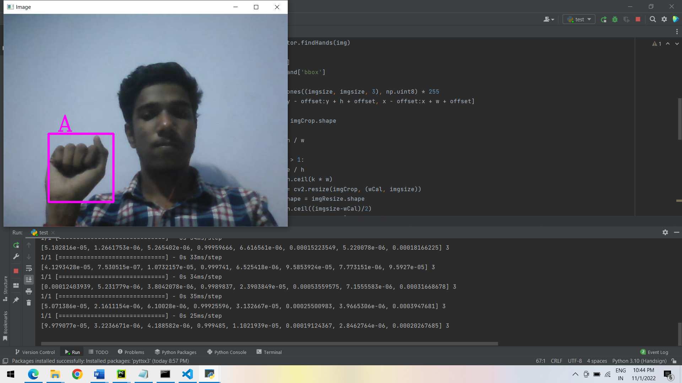

**Fig 3.2.7 Hand Detected and Letter recognize**

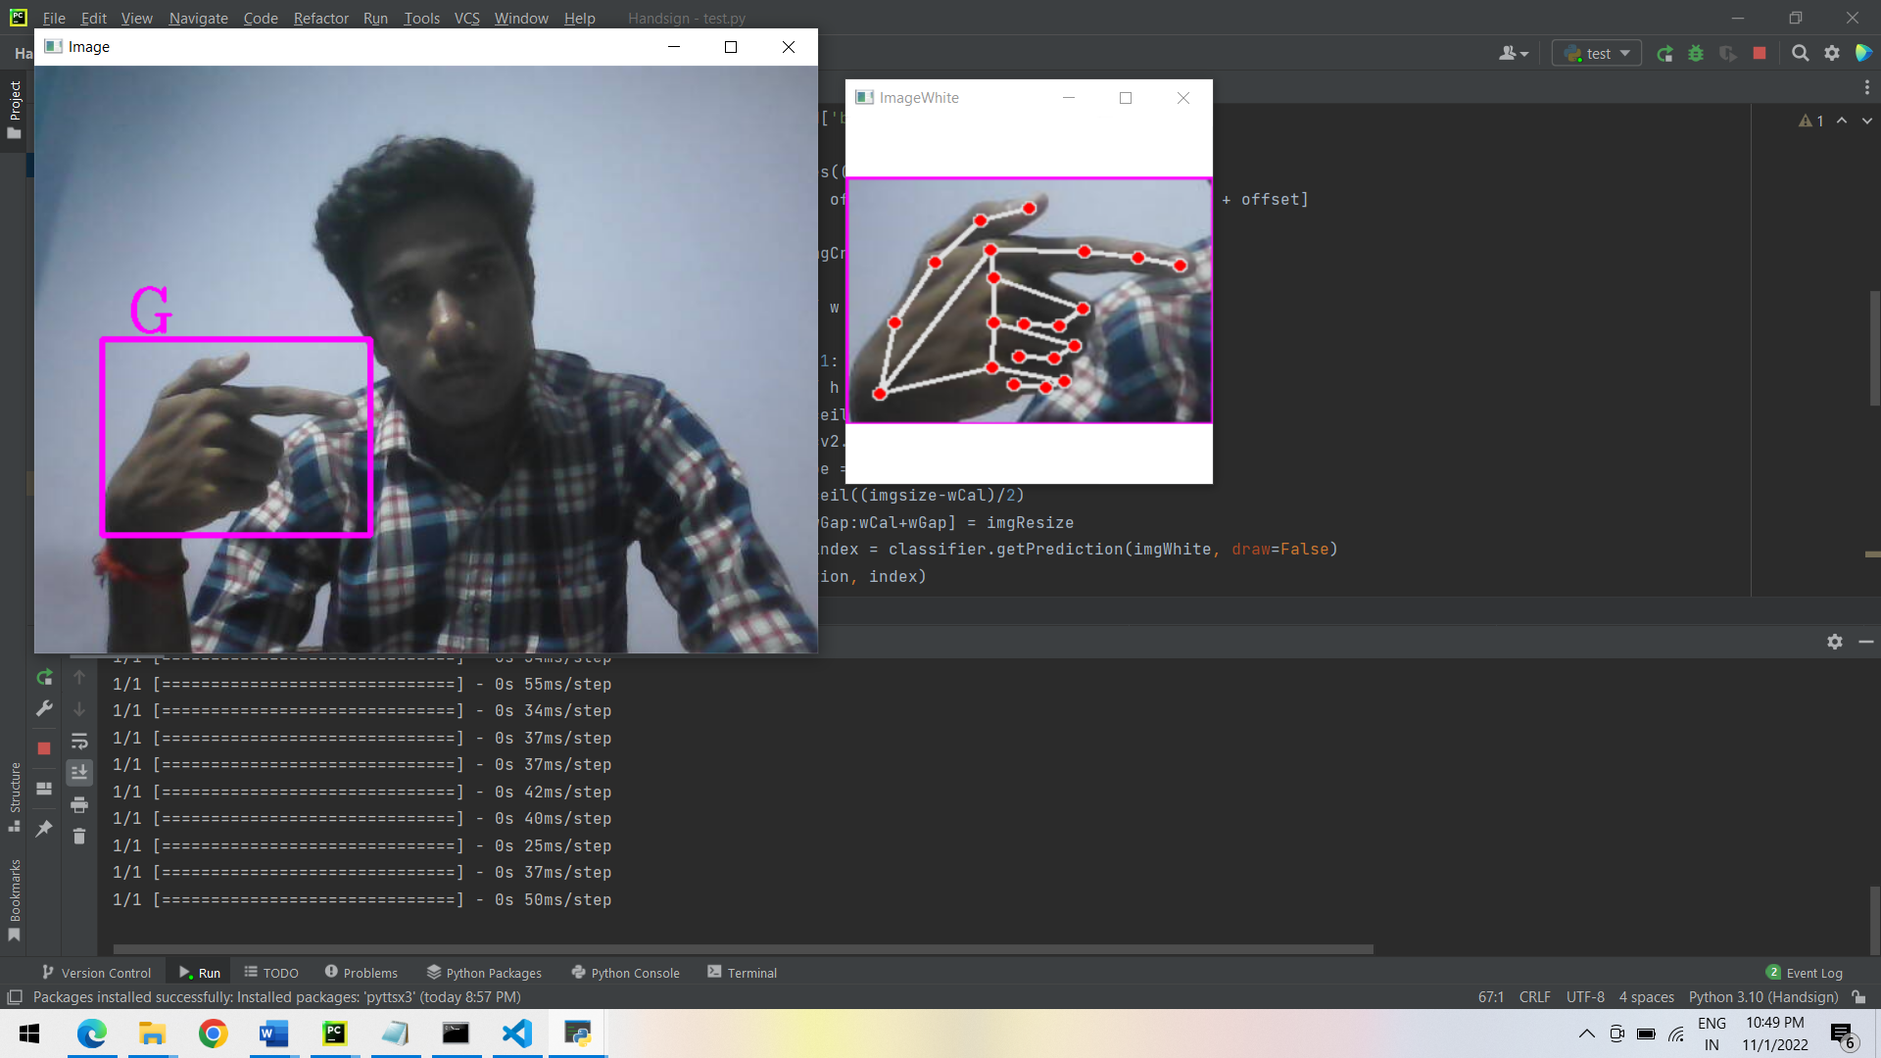

**Fig 3.2.8 Hands Detection and Scanning points**

**CHAPTER 4**

# CONCLUSION AND FUTURE SCOPE

**CONCLUSION:-**

The sensor less sign language and gesture recognition system is a module which provides an easy and satisfactory user communication for deaf and dumb people. The module provides two way communications which helps in easy interaction between the normal people and disables. The system is novel approach to ease the difficulty in communicating with those having speech and vocal disabilities. The aim is to provide an application to the society to establish the ease of communication between the deaf and mute people by making use of image processing algorithm. Since it follows an image based approach it can be launched as an application in any minimal system and hence has near zero-cost.

**FUTURE SCOPE:-**

1. We can develop a model for ISL word and sentence-level recognition. This will require a system that can detect changes with respect to the temporal space.

2. We can develop a complete product that will help speech and hearing-impaired people, and thereby reduce the communication gap.

**CHAPTER 5**

# REFERENCES

* [**https://youtu.be/xtk14TcWaN4**](https://youtu.be/xtk14TcWaN4)**.**
* [**https://sourceforge.net/projects/mingw/**](https://sourceforge.net/projects/mingw/)
* [**https://github.com/Adv-learning/login system_c/blob/main/login.cpp**](https://github.com/Adv-learning/login_system_c/blob/main/login.cpp)
* [Download PyCharm: Python IDE for Professional Developers by JetBrains](https://www.jetbrains.com/pycharm/download/#section=windows)
* **https://www.bing.com/images/search?view=detailV2&ccid=2jy%2f%2fMs7&id=335B0CBAC37B7FA54D6F33CAB998EC85FA02DE65&thid=OIP.2jy__Ms7PO0uO5Q4O2ngcgHaMV&m**